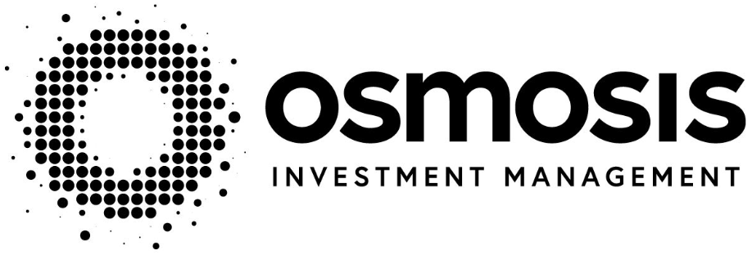
Key Investor Information

This document provides you with key investor information about this Fund. It is not marketing material. The information is required by law to help you understand the nature and the risks of investing in this Fund. You are advised to read it so you can make an informed decision about whether to invest.
(ISIN: IE00BF0D3F98, Share Class: A USD)
This Fund is managed by Prescient Fund Services (Ireland) Limited (the “Manager”)
Osmosis Resource Efficient Core Equity Fund (the "Fund")
a sub-Fund of OSMOSIS ICAV (the "ICAV")
Objectives and Investment Policy

The Fund's goal is to achieve growth of the Fund's value in the medium to long term.

The Fund invests in shares of large companies, which may be located in developed countries worldwide.

The Investment Manager selects stocks of companies using the Osmosis Model of Resource Efficiency (the “MoRE Model”). The MoRE Model has been developed by the Investment Manager to rate companies on resource efficiency by compiling information on energy, waste and water. The Fund has a global investment strategy, with no particular target in relation to any industrial, geographic or other market sectors.

The Fund may also invest up to 10% of its net aset value in cash equivalents and money market instruments. The Fund may also invest up to 10% of its net asset value in collective investment schemes.

The Fund may invest in limited Financial Derivatives ("FDIs") for investment purposes and efficient portfolio management, including for hedging purposes.

The Fund’s base currency is US dollars.

Portfolio transaction costs may have an impact on the Fund’s performance. Portfolio transaction costs are paid out of the assets of the Fund, in addition to the charges set out below.

This Fund is actively managed in reference to the MSCI World Index (the "Benchmark") by virtue of the fact that the investment objective of the Fund is to outperform the Benchmark. The Investment Manager has discretion to invest in securities not included in the Benchmark at any time in order to take advantage of investment opportunities. The investment strategy will restrict the extent to which the Fund’s holdings may deviate from the Benchmark. This deviation may be material.

Any income arising from the Fund will be reinvested and it is not intended that the Fund will pay dividends.

Unless otherwise defined in this document, all words and expressions defined in the Fund's current Prospectus shall have the same meaning herein.

You may buy and sell shares in the Fund on any day (except Saturday or Sunday) on which banks in Ireland and England are generally open for business.

Please refer to the “Investment Objectives and Policies” section of the Prospectus for further information.

Risk and Reward Profile of the Fund

Lower Risk Higher Risk

Typically lower rewards Typically Higher Rewards

1 | 2 | 3 | 4 | 5 | 6 | 7

The indicator above is not a measure of the risk of capital loss, but a measure of the Fund's price movement over time.

- It is based on historical data and thus may not be a reliable indication for the future.

- The indicated risk category is not guaranteed and may shift over time.

- The indicator is designed to help investors understand the uncertainties both for loss and for growth that may affect their investment. A category 1 fund is not a risk free investment, the risk of loss is small but the chance of making gains may also be limited. With a category 7 fund, the risk of losing money is high but so also is the possibility of making gains.

- The Fund is classified in the category indicated above due to its target asset mix.

- The Fund does not provide its investors with any guarantee on performance, nor on the monies invested in it.

In addition to the risk captured by the indicator, the overall Fund value may be considerably affected by:
- Equity Risk - the Fund invests in shares of companies, and the value of these shares can be negatively affected by changes in the company or its industry or the economy in which it operates.

- Exchange Rate Risk - changes in exchange rates between the currencies of investments held by the Fund and the Fund's base currency may negatively affect the value of an investment.
- Operational Risk - the Fund is subject to the risk of loss resulting from inadequate or failed internal processes, people or systems or those of third parties such as those responsible for the custody of its assets.

- Liquidity Risk - the risk stemming from the lack of marketability of an investment that cannot be bought or sold quickly enough to prevent or minimise a loss.

- Derivatives Risk - Derivatives are highly sensitive to changes in the value of the assets which they are based on.

Please refer to the “Risk Factors” section of the Prospectus for further information - see under “Practical Information” for how to obtain a copy.

Charges for the Fund
These charges are used to pay the costs of running the Fund, including the costs of marketing and distribution. These charges reduce the potential growth of your investment.
The Exit and Entry charges shown are maximum figures. It is possible that you will pay substantially less, or there will be no charges at all. You can find out the actual entry and exit charges from your financial advisor, the distributor or the Manager of the Fund.
One-off charges taken before or after you invest
Entry charge 5.00%
Exit charge 3.00%

This is the maximum that might be taken out of your money before it is invested or before the proceeds of your investment are paid out.
Charges taken from the Fund over a year

Ongoing charges 0.20%
Charges taken from the Fund under certain specific conditions

Performance Fee 0.00%

While a switching charge of up to a maximum of 3% of the subscription price may apply, it is not currently intended that any such charge will be applied.

The ongoing charges figure is based on the expenses of the year ending 31 December 2023. This figure may vary from year to year. It excludes portfolio transaction costs, except in the case of an entry or exit charge paid by the UCITS when buying or selling units in another UCITS or collective investment undertaking.

You can find more details about the charges in the section of the Fund’s Prospectus entitled Fees and Expenses. The chart shows the Fund's annual performance in USD for each full calendar year over the period displayed in the chart. It is expressed as a percentage change of the Fund's net asset value at each year-end.
Past Performance
SD

The Fund was launched in 2017 and this share class was launched in 2017.

Performance is shown after deduction of ongoing charges. Any entry/exit charges are excluded from the calculation.

Past performance is based on the net asset value (NAV) of the Fund and is not a reliable indicator of future results

Practical Information

Fund Depositary: Northern Trust Fiduciary Services (Ireland) Limited

Further Information: Copies of the Prospectus of Osmosis ICAV and the annual and half-yearly reports of the Fund are available in English and may be obtained, free of charge, from the Administrator, the Investment Manager and also from the “Manager” at 35 Merrion Square East, Dublin 2, Ireland or by visiting www.prescient.ie.
Share Price / NAV: The net asset value of the Fund is calculated in USD. The share prices are published in USD on each Business Day. The prices are available from the Investment Manager and the Manager during normal business hours and will be published on Prescient Fund Services (Ireland)’s website at www.prescient.ie.

Taxation: The Fund is subject to tax laws and regulations of Ireland. Depending on your home country of residence, this might have an impact on your investment. For further details, please speak to an adviser.
Switches: You are entitled to switch your shares to shares in another class of the Fund or into a class of another sub-fund of Osmosis ICAV, subject to the sub-fund’s switching charge - see under “Charges for this Fund”. Please refer to the Prospectus for further information on how to switch.

Fund Structure: This document describes the Class A USD Shares of the Osmosis Resource Efficient Core Equity Fund, a sub-fund of Osmosis ICAV but is also considered representative of the other Class A EUR and GBP share classes of this Fund. Information relating to all of the share classes is available in the Prospectus and the Supplement.
The assets and liabilities of each sub-Fund of Osmosis ICAV are segregated subject to the provisions of Irish law. The Prospectus is prepared for Osmosis ICAV in its entirety. The ICAV may prepare separate periodic reports with respect to each sub-fund of the ICAV or periodic reports for the umbrella ICAV. You can find out more information about Osmosis ICAV in the Prospectus.

Remuneration: Details of the up-to-date remuneration policy of the Manager, including, but not limited to, a description of how remuneration and benefits are calculated, the identity of persons responsible for awarding the remuneration and benefits including the composition of the remuneration committee, if any, are available at www.prescient.ie. A paper copy of the remuneration policy will be made available free of charge upon request from the Manager.

Responsibility for Information: The Manager may be held liable solely on the basis of any statement contained in this document that is misleading, inaccurate or inconsistent with the relevant parts of the Prospectus for the Fund.

Osmosis ICAV was authorised with effect from 7 April 2017 pursuant to the UCITS Regulations. Prescient Fund Services (Ireland) Limited was authorised in Ireland on 18 March 2011 and is regulated by the Central Bank of Ireland.This Key Information Document is accurate as at 07 February 2024.

